FINAL PROJECT REPORT

MEDICINE REMINDER SYSTEM
A MERN Stack Application

Submitted by | A.kaveri  B.Akshitha Reddy  R.Pravallika  V.Mayuri
Roll Number(s) | 25MVCSMR0096  25MVCSMR0107  25MVCSMR0168  25MVCSMR0183
Department | CSE-AI/ML
College | Malla Reddy Viswavidyapeeth technical campus
Project Guide | [Guide Name]
Academic Year | 2025-2029

2. Abstract & Introduction

2.1 Abstract
The Medicine Reminder System is a web application project intended to help users organise medicine schedules. The system manages medicine-related details such as medicine name, dosage, scheduled time, start date, and end date. The project uses the MERN stack: MongoDB for data storage, Express.js and Node.js for backend API development, and React.js for the user interface. The main data-management operations are creating, viewing, updating, and managing medicine records. The application is intended to present medicine schedule information clearly so that users can refer to their recorded schedules. The exact reminder delivery method, authentication flow, and implemented features should be documented according to the completed build.

2.2 Introduction
Medicine schedules may include different medicines, dosages, timings, and date ranges. Keeping these details organised in one place can make schedule information easier to review. A digital medicine reminder application provides a structured interface for entering and managing these records.
This project applies full-stack web development concepts. React.js provides the client-side interface, Node.js runs the server-side JavaScript environment, Express.js defines backend routes, and MongoDB stores medicine records. The frontend communicates with the backend through REST APIs.

2.5 Purpose of the Project
- Demonstrate development of a full-stack application using the MERN stack.
- Implement medicine record management with MongoDB.
- Build REST APIs using Node.js and Express.js.
- Develop an interactive frontend using React.js.
- Apply validation and authentication controls where they are part of the implementation.

3. Problem Statement, Objectives & Scope

3.1 Problem Statement
Build a MERN-based medicine reminder system that manages medicine schedules, including medicine name, dosage, scheduled time, start date, and end date. The application should use MongoDB to store relevant records, React.js for the user interface, and Node.js with Express.js to provide backend APIs. It should support the main record operations required by the project.

3.2 Objectives
- Demonstrate MERN stack development.
- Implement CRUD operations using MongoDB.
- Build REST APIs using Node.js and Express.js.
- Develop the frontend using React.js.
- Implement authentication and role-based access where required by the project.
- Display project information and results clearly.

3.3 Project Scope
The defined scope covers the management of medicine schedule records and the full-stack components needed to create, retrieve, update, and manage those records. The exact scope of reminders, user roles, reporting, and notifications depends on the features included in the completed version.

3.4 Target Users
- Users who want to keep medicine schedule details organised.
- An administrator, if an administrative role is implemented, to manage access or records as defined by the application.

3.5 Assumptions and Limitations
- The schedule information is entered by the user and should follow instructions from a qualified healthcare professional.
- The application is an organisational aid; it does not diagnose conditions or determine medicine dosage.
- Reminder delivery can depend on the implementation, browser/device permissions, and whether the application is running.
- Only features verified in the submitted application should be described as implemented.

4. Features & Functional Requirements

4.1 Core Features
- Add a medicine record containing the fields supported by the application, including medicine name, dosage, time, and start/end dates.
- View saved medicine records.
- Update an existing medicine record.
- Manage or remove records, according to the operations implemented.
- Validate required inputs before saving records.
- Display medicine schedule information in a clear interface.
Optional features such as sign-in/sign-up, role-based access, browser notifications, dose history, search, and filtering should be retained in this section only if they are implemented in the completed project.

4.2 Functional Requirements
ID | Requirement
FR-01 | The system should accept medicine schedule details through the user interface.
FR-02 | The system should send a request to the backend to create a medicine record.
FR-03 | The system should retrieve and display saved medicine records.
FR-04 | The system should allow supported fields in a record to be updated.
FR-05 | The system should support the record-management operation included in the implementation, such as deletion.
FR-06 | The system should validate required fields and handle invalid requests.
FR-07 | The system should return clear success or error responses to the frontend.

4.4 Authentication and Validation
Authentication and role-based access should be documented according to the implemented design. If authentication is included, describe the sign-in/sign-up process, how protected routes are handled, and which roles can access each operation. Validation should check required fields and acceptable date/time formats. Backend validation is important even when frontend validation is also used.

4.5 System Requirements
- Hardware: a computer or laptop capable of running a modern web browser and the development environment.
- Software: a supported operating system, Node.js and npm, MongoDB or a MongoDB-hosted database, and a modern web browser.
- Development tools: code editor and API testing tool, if used.

5. Algorithms & Methodology

5.1 System Workflow
- The user opens the medicine reminder application.
- The frontend displays the relevant page or form.
- The user enters medicine schedule details or selects an existing record.
- React sends an HTTP request to the backend API.
- Express.js receives the request and validates the supplied data.
- The backend performs the requested database operation using MongoDB.
- The backend returns a response indicating the outcome.
- The frontend displays the updated record list or an appropriate message.

5.2 Main Algorithm: Save a Medicine Record
- Start.
- Read the medicine details entered in the form.
- Check that required fields are present and values are valid.
- If validation fails, display an error and stop the save operation.
- If validation succeeds, send the record to the backend API.
- The backend validates the request and stores the record in MongoDB.
- Return the operation result to the frontend.
- Display confirmation and refresh the relevant medicine list when the operation succeeds.
- End.

5.3 Algorithm: Update a Medicine Record
- Select the record to update.
- Display its existing details in an editable form.
- Accept the changed values and validate them.
- Send the update request with the record identifier.
- The backend locates the record and applies the supported changes.
- Return the result and display the updated record.

5.4 Development Methodology
A component-based full-stack workflow is suitable for this project: define requirements, design the data fields and API routes, develop the backend and database operations, build the React interface, connect the frontend to the APIs, validate the flows, and test the completed build. The actual sequence followed by the project team may be added here if it differed.

5.5 Data Flow
User input → React frontend → HTTP/REST API request → Express.js route and validation → MongoDB operation → API response → React interface update.

6. Technologies & Implementation

6.1 Frontend Technologies
- React.js: builds the user interface and reusable components.
- HTML and CSS: structure and style the interface.
- JavaScript: handles client-side interactions and API communication.

6.2 Backend Technologies
- Node.js: JavaScript runtime for the server.
- Express.js: defines REST API routes and request/response handling.

6.3 Database
MongoDB is the database specified for storing medicine schedule records. A record may contain fields such as medicine name, dosage, time, start date, and end date. The exact schema, field names, data types, and any user identifier should match the actual model in the application.

6.4 Tools and APIs
Tools used: [Enter your actual editor, API testing tool, version-control tool, and deployment service, if applicable]. API endpoints: [List the actual HTTP methods and routes implemented in your project].

6.5 Implementation Details
The application follows a client-server structure. The React frontend collects and displays information. The backend exposes API endpoints for medicine-record operations, and MongoDB stores the records. The frontend communicates with the backend through HTTP requests.
Complete this subsection with the actual implementation: component names, model/schema fields, endpoint paths, validation rules, authentication approach, reminder mechanism, and deployment details. These particulars were not included in the supplied project description and therefore are intentionally not fabricated in this report.

7. Results, Testing & Performance

7.1 Project Results
The project is reported by the student as completed. The application’s actual output, screenshots, and verified feature behaviour should be inserted in this section. The problem statement establishes the intended medicine schedule management and CRUD scope, but no execution logs, screenshots, or test results were supplied with the report request; therefore, this document does not claim specific tests passed.
Screenshots to insert:
- Screenshot 1: Log in

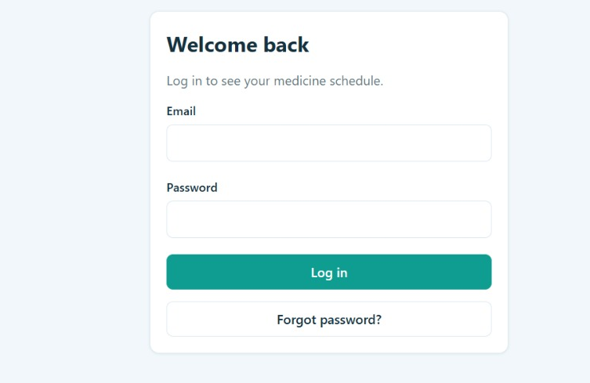

- Screenshot 2: Dashboard
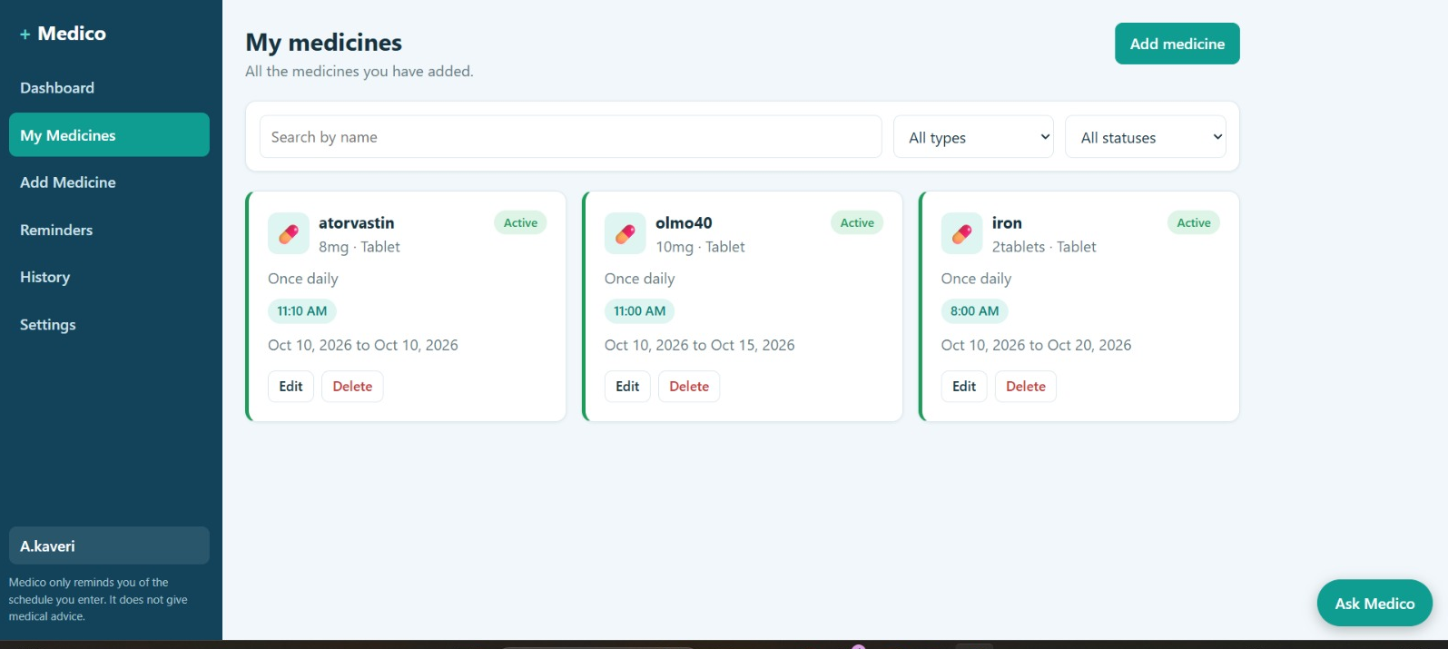

- Screenshot 3: Medicine list / view record
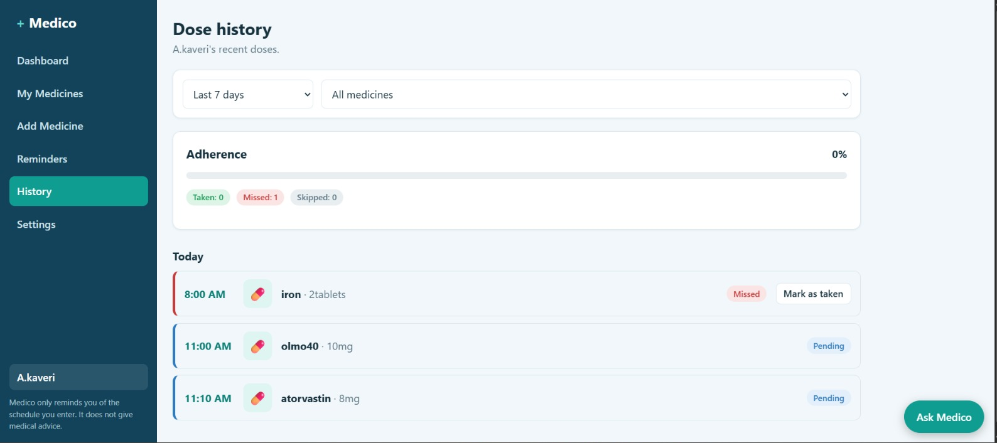

- Screenshot 4: Update or manage record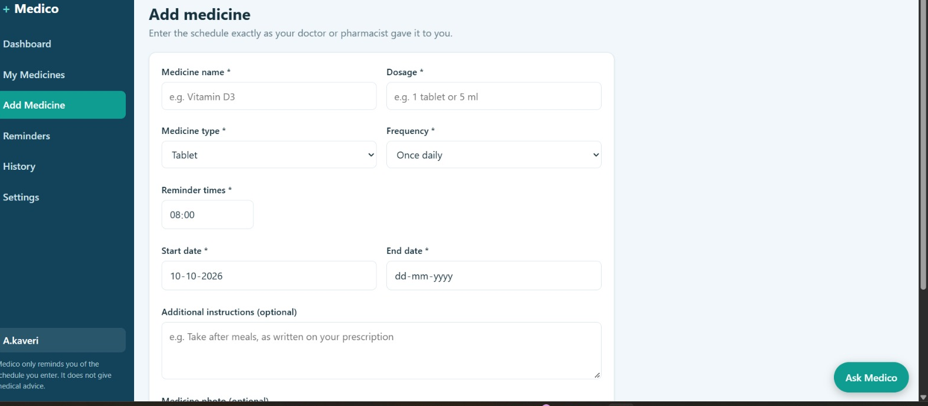
- Screenshot 5: Reminder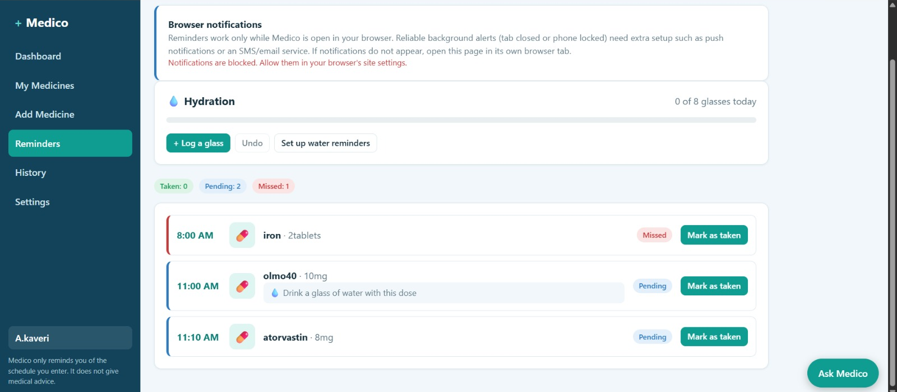

7.2 Testing Methods
- Functional testing: verify each implemented operation through the user interface.
- API testing: verify actual backend routes, response codes, and response bodies using the tool used by the team.
- Validation testing: try missing or invalid field values.
- Integration testing: verify that frontend requests correctly reach the backend and database.
- Authentication testing: perform only if authentication and protected routes are implemented.

8. Conclusion, Future Scope & References

8.1 Conclusion
The Medicine Reminder System is a MERN stack project focused on organising medicine schedule information. Its defined purpose is to manage medicine name, dosage, time, and date range through a React interface, backend APIs, and MongoDB storage. The project provides an opportunity to demonstrate frontend development, REST API design, database operations, and CRUD concepts. The final conclusion should be updated to reflect the features and test results verified in the submitted build.

8.2 Future Scope
- Add browser or mobile notifications, if not already implemented, with clear permission handling.
- Add recurring schedules and configurable reminder preferences.
- Add a dose history or adherence summary, if appropriate for the project scope.
- Add caregiver sharing with explicit user consent and access controls.
- Improve accessibility, responsive layout, and input validation.
- Add backup and recovery procedures for stored records.
These are possible enhancements, not claims that the features are currently present. Any health-related decisions must remain based on instructions from a qualified healthcare professional.

8.3 References / Documentation
- React documentation — https://react.dev/
- Node.js documentation — https://nodejs.org/docs/
- Express.js documentation — https://expressjs.com/
- MongoDB documentation — https://www.mongodb.com/docs/
- MDN Web Docs (HTML, CSS, and JavaScript) — https://developer.mozilla.org/
Add any libraries, tutorials, APIs, and other materials actually used by the team. Include access dates if required by your college’s report format.

